**Łódź, December 4th 2024**

**Market Research No. 30-24-pk study**

The subject of the order is to carry out a pk study on rats and dogs for the implementation of a commercial project as part of the Competition for the development of targeted or personalized medicine based on medicinal products based on nucleic acids and small-molecule compounds, co-financed by the Medical Research Agency.

**Ordering Party:** FiLeClo Ltd., Al. Piłsudskiego 141, 92-318 Łódź, NIP 7282829858

**1. Description of the order**

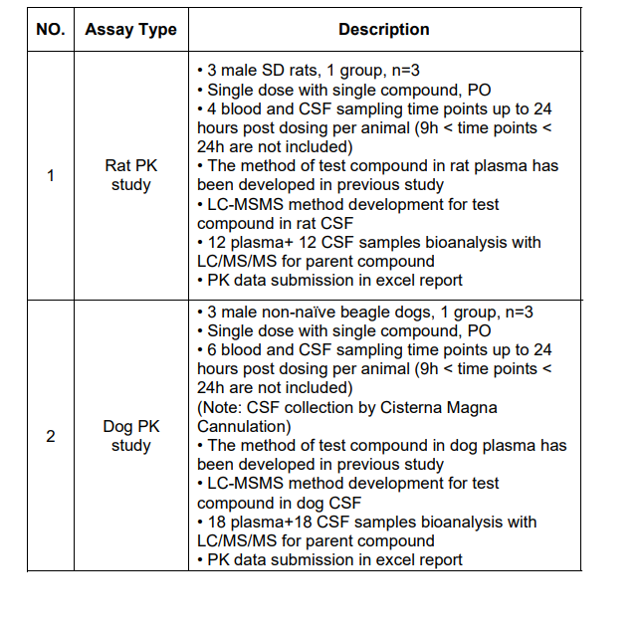

**2. Conditions for participation in the market research**

**Economic and financial situation**

The proceedings may be attended by entities that are in a financial situation that ensures the implementation of the subject of the order and those for which bankruptcy/liquidation proceedings have not been initiated or for which bankruptcy/liquidation has not been announced.

**Additional conditions**

1. The ordering party reserves the right to cancel the market research without stating a reason.
2. In the event of cancellation of the market research, bidders are not entitled to claim reimbursement of participation costs.
3. The withdrawal by the ordering party from concluding the contract upon notifying the bidder of the selection of their offer cannot be the basis for claims for participation costs.
4. During the evaluation of submitted offers, the ordering party may request explanations from bidders regarding the content of the documents submitted by them.
5. The ordering party reserves the right to negotiate offers with the bidder whose offer has received the highest number of points, especially if the price offered by the bidder exceeds the budget allocated by the ordering party for the execution of the given order.
6. The validity of the submitted offer is 14 days from the deadline for submission of offers.

**Conditions for changing the contract**

The ordering party will sign a contract with the selected bidder for the execution of the service within no more than 14 days from the date of completion of the selection procedure.

The ordering party reserves the right to amend the contract concluded with the bidder selected as a result of this inquiry, for the following reasons:

1. force majeure circumstances, e.g., an unforeseen event caused by external factors that could not have been predicted with certainty, especially those directly threatening human life or health or posing a risk of significant damage;
2. actions of third parties preventing the execution of the work, which are not the fault of either party to the contract. Any change in the order execution date is subject to acceptance by the ordering party and possibly the Intermediary Institution financing the project (according to the provisions of the funding agreement);
3. the occurrence of another, unforeseeable legal, economic, or technical circumstance at the time of concluding the contract, for which neither party is responsible, resulting in the inability to properly execute the contract in accordance with the provisions of the inquiry;
4. changes in legal regulations in force on the day of signing the contract.

**List of documents/statements required from the Contractor**

Annex No. 1 – Offer Form

**Supplementary orders**

Supplementary orders can be placed with the selected bidder only if they align with the main purpose of this order and do not exceed 50% of the value of this order.

**3. Place and method of submitting offers**

1. Deadline for submitting offers: **11th December 2024**. Offers submitted after the deadline will not be considered.
2. The offer, along with the required attachments, should be submitted electronically to the email address: **granty@fileclo.pl** or **pilaszek@trimen.pl** The subject of the message should include the inquiry number i.e., **30-24-pk study**
3. Contact person regarding the announcement: Przemysław Pilaszek, +48 602 306 668

**4. Offer evaluation criteria**

Net price of the lowest offer/net price of the evaluated offer x 100% = number of points

1. The most advantageous offer will be considered the one that obtains the highest number of points.
2. If two or more offers receive the same number of points, the ordering party will conduct price negotiations with the bidders and select the most advantageous offer in terms of price.